

Market Consultation Solactive Lloyd Growth Equity Index

11 July 2025

Content of the Market Consultation
Solactive AG has decided to conduct a Market Consultation with regard to changing the Index Methodology of the following Indices (the ‘Indices’):
NAME | RIC | ISIN
Solactive Lloyd Growth Equity Index CNTR | .SGEPNTRC | DE000SL0K310
Solactive Lloyd Growth Equity Index PR | .SGEPPRP | DE000SL0K302
Solactive Lloyd Growth Equity Index TR | .SGEPTRT | DE000SL0K328

Rationale for the Market Consultation
In this methodology change, Solactive aims at detailing and clarifying the rules the Selection Party is following to build the index universe, select the constituents and assign a weight to final constituents. We clarify the conditions leading to an Extraordinary Rebalance. We also move the rebalancing to end of month.

Proposed Changes to the Index Guideline
The following Methodology changes are proposed in the following points of the Index Guideline (ordered in accordance with the numbering of the affected sections):

Section 2.1 Index Universe Requirements

From:
[…]
- Securities with above average Return on Tangible Equity, Solvency Ratio, and Credit Rating if they are in Financial sectors, including Bank and Insurance.
The Approval Committee has the authority on each Selection Day to include and/or exclude securities that fulfill the Index Universe Requirements (as specified in Section 2.1).

[…]
To:
[…]
- Securities with above average Return on Tangible Equity, Solvency Ratio, and Credit Rating if they are in Financial sectors, including Bank and Insurance.
- Securities with country of domicile classified as Emerging Markets that show outstanding Combined Ratio and Margin of Safety.
- Securities classified as "Super Growers", defined as securities with an expected revenue growth of at least 20% over the next 5 years or at least 15% over the next 10 years, while demonstrating current positive Free Cash Flow (FCF).
The Approval Committee has the authority on each Selection Day to include and/or exclude securities that fulfill the Index Universe Requirements (as specified in Section 2.1).
[…]

We allow the Selection Party to include EM listed securities if they show outstanding performances, in accordance with the scope of the Index. We also give the opportunity to the Selection Party to include “Super Growers”.

Section 2.2 Selection of the Index Components

From:
[…]
Ultimately, securities that meet the following criteria are eligible for inclusion:
- A Combined Ratio equal to or larger than 3.
- A Margin of Safety equal to or larger than 20%.
- Double-digit growth in Free Cash Flow over a period of seven to ten years or high single-digit growth over more than ten years.

To:
[…]
Ultimately, securities that meet the following criteria are eligible for inclusion:
- A Combined Ratio equal to or larger than 3.
- A Margin of Safety equal to or larger than 20%.
- Double-digit growth in Free Cash Flow over a period of seven to ten years or high single-digit growth over more than ten years.

The Selection Party will select the Index Components among the list of eligible securities that meet the criteria set forth in Section 2.2, incorporating sectoral and geographic diversification imperatives, as well as additional qualitative elements gathered during interviews with the management, industry experts, and the issuer’s customers and suppliers.
[…]

We’re detailing the process of the selection party to select the final index constituents.

Section 2.3 Weighting of the Index components

From:
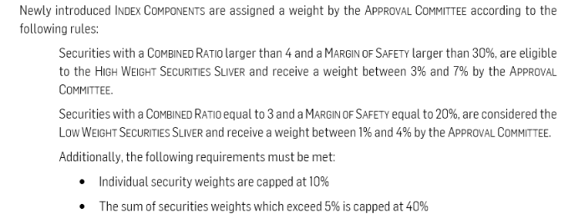
[…]
To:
[…]
Securities with a Combined Ratio larger than 4 and a Margin of Safety larger than 30%, are eligible to the High Weight Securities Sliver and receive a weight between 3% and 10% by the Approval Committee.
Securities with a Combined Ratio equal to 3 and a Margin of Safety equal to 20%, are considered eligible to the Low Weight Securities Sliver and receive a weight between 1% and 4% by the Approval Committee.
[…]
We remove the weight capping to reflect the methodology of the selection party in the weighting scheme of the Index.

Section 2.3 Weighting of the Index Components

From:
[…]
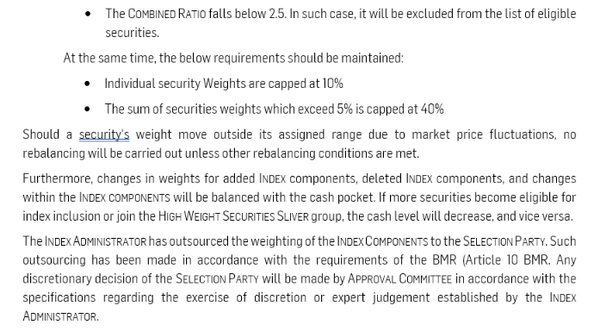
[…]

To:
[…]
- The Combined Ratio falls below 2.5. In such case, it will be excluded from the list of eligible securities.

The Selection Party will select the Index Components of the High Weight Securities Sliver and Low Weight Securities Sliver among the list of eligible securities meeting the criteria set forth in Section 2.3, incorporating sectoral and geographic diversification imperatives, as well as additional qualitative elements gathered during interviews with the management, industry experts, and the issuer’s customers and suppliers.
The Selection Party assigns the weight within the defined range factoring such elements.
In addition, securities that have already been selected as Index Components (in accordance with Section 2.2) and assigned to either the High Weight Securities Sliver or Low Weight Securities Sliver group may have their weight adjusted (increased or decreased) within the respective predefined ranges of 3% to 10% for High Weight Securities Sliver and 1% to 4% for Low Weight Securities Sliver.
Should a security's weight move outside its assigned range due to market price fluctuations, no rebalancing will be carried out unless other rebalancing conditions are met.
Furthermore, changes in weights for added Index components, deleted Index components, and changes within the Index components will be balanced with the cash pocket. If more securities become eligible for index inclusion or join the High Weight Securities Sliver group, the cash level will decrease, and vice versa.
The Index Administrator has outsourced the weighting of the Index Components to the Selection Party. Such outsourcing has been made in accordance with the requirements of the BMR (Article 10 BMR. Any discretionary decision of the Selection Party will be made by Approval Committee in accordance with the specifications regarding the exercise of discretion or expert judgement established by the Index Administrator.
[…]

We clarify the process of the Selection Party in the weighting of the final index constituents.

Section 3.2 Extraordinary Rebalance

From:

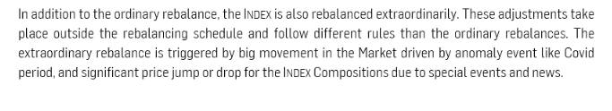

To:

In addition to the ordinary rebalance, the Index is also rebalanced on an extraordinary basis. These adjustments take place outside the ordinary rebalancing schedule and are triggered by any event that causes a significant deviation in the criteria defined for the Combined Earnings Power Risk Score and Combined Ratio (as outlined in Section 2.2), resulting in a material change to the Index Components.
The Index Administrator has outsourced the determination of the Extraordinary Rebalance to the Selection Party. Such outsourcing has been made in accordance with the requirements of the BMR (Article 10 BMR). Any discretionary decision of the Selection Party will be made by Approval Committee in accordance with the specifications regarding the exercise of discretion or expert judgement established by the Index Administrator.

Section 6. Definitions

From:
[…]
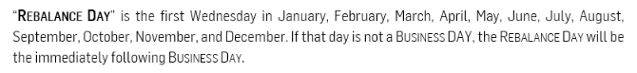
[…]

To:
[…]
“Rebalance Day” is 2 weekdays (Monday to Friday) before the last weekday (Monday to Friday) of each month. If the Rebalance Day is not a Business DAY, the Rebalance Day will be the immediately preceding Business Day.
[…]

We’re moving the Rebalance Day earlier to make it match end of month.

Feedback on the proposed changes
If you would like to share your thoughts with Solactive, please use this consultation form and provide us with your personal details and those of your organization.

Name
Function
Organization
Email
Phone
Confidentiality (Y/N)

Solactive is inviting all stakeholders and interested third parties to evaluate the proposed changes to the Methodology for the Solactive Lloyd Growth Equity Index and welcomes any feedback on how this may affect and/or improve their use of Solactive indices.

Consultation Procedure
Stakeholders and third parties who are interested in participating in this Market Consultation, are invited to respond until 2025-07-24.
[Subject to feedback received on this Market Consultation, the changes mentioned above are intended to become effective on 2025-08-08.

Please send your feedback via email to marketconsultation@solactive.com, specifying “Market Consultation Solactive Lloyd Growth Equity Index” as the subject of the email, or
via postal mail to: Solactive AG
Platz der Einheit 1
60327 Frankfurt am Main
Germany

Should you have any additional questions regarding the consultative question in particular, please do not hesitate to contact us via above email address.

Contact
Solactive AG
German Index Engineering
Platz der Einheit 1
60327 Frankfurt am Main
Germany
Tel.: +49 (0) 69 719 160 00
Fax: +49 (0) 69 719 160 25
Email: info@solactive.com
Website: www.solactive.com

© Solactive AG

